SDE
30 September 2024 11:33
QUESTION 1
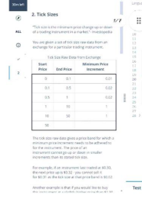 | 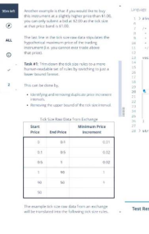
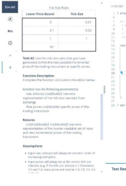 | 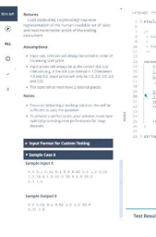

#include <iostream>
#include <vector>
#include <algorithm>
#include <iomanip>
using namespace std;
Squarepoint Page 1
using namespace std;
struct TickSizeRule {
double lowerPriceBound;
double tickSize;
};
void trimTickSizeRules(const vector<vector<double>> &raw_tickSizes, vector<TickSizeRule> &tickSizeRules) {
double prevLower = raw_tickSizes[0][0];
double prevTickSize = raw_tickSizes[0][2];
tickSizeRules.push_back({prevLower, prevTickSize});
for (int i = 1; i < raw_tickSizes.size(); ++i) {
double currentLower = raw_tickSizes[i][0];
double currentTickSize = [i][2];
if (currentTickSize != prevTickSize) {
tickSizeRules.push_back({currentLower, currentTickSize});
prevTickSize = currentTickSize;
}
}
}
double findNextIncrement(double price, const vector<TickSizeRule> &tickSizeRules) {
auto it = lower_bound(tickSizeRules.begin(), tickSizeRules.end(), price, [](const TickSizeRule &rule, double value) {
return rule.lowerPriceBound <= value;
});
if (it != tickSizeRules.begin()) {
--it;
}

return price + it->tickSize;
}
int main() {
vector<vector<double>> raw_tickSizes = {
{0.0, 0.2, 0.1},
{0.2, 0.6, 0.2},
{0.6, 1.0, 0.2},
Squarepoint Page 2
{1.0, 1.1, 0.1},
{1.1, 1.6, 0.5},
{1.6,2.8,0.3},
{2.8}
};
vector<double> prices = {0.5,1.3,2};
vector<TickSizeRule> tickSizeRules;
trimTickSizeRules(raw_tickSizes, tickSizeRules);
for (const auto &rule : tickSizeRules) {
cout << fixed << setprecision(2) << rule.lowerPriceBound << " " << rule.tickSize << endl; }
for (double price : prices) {
double nextPrice = findNextIncrement(price, tickSizeRules);
cout << fixed << setprecision(2) << nextPrice << endl;
}
return 0;
}
QUESTION 2
https://leetcode.com/problems/search-suggestions-system/description/?envType=problem-list-v2 &envId=trie
Input: vector of strings named words, string named search
Todo: Think of a search engine that has the words vector as its database. string search is your current keyword. You start typing the search word and your search engine starts giving 3 suggestions whose prefixes match the current state of your search word. So, as you write the search word character by character, you get a new recommendation list suited for that. If there are more than three words in the database that are suited, return the three lexicographically smallest ones. If there are none, return empty list.
Output: A vector<vector<string>> which contains the recommendations for all characters being typed one by one.
Example: words : ["cart", "carpet", "carpool", "call" ], search: carl
output:
[
c : ["call", "carpet", "carpool"],
ca : ["call", "carpet", "carpool"],
car : ["carpet", "carpool", "cart"],
carl : []
]
Squarepoint Page 3
]
#include <bits/stdc++.h>
#define ll long long
class Solution {
public:
vector<vector<string>> suggestedProducts(vector<string>& products, string searchWord) {
sort(products.begin(), products.end());
vector<vector<string>>result;
string currentPrefix = "";
for(auto&c : searchWord){
currentPrefix+=c; // Build the prefix incrementally
vector<string> suggestions;
// Use lower_bound to find the first product that is not less than the current prefix
auto it = lower_bound(products.begin(), products.end(), currentPrefix); // Collect up to three valid suggestions
int i = 0;
while(i < 3 && it != products.end() && it->substr(0, currentPrefix.size()) == currentPrefix){
suggestions.push_back(*it);
++i;
++it;
}
result.push_back(suggestions);
}
return result;
}
};
QUESTION 3:
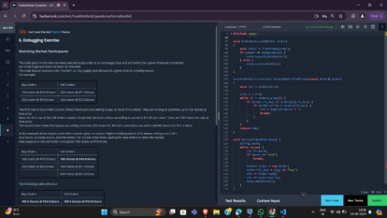 Squarepoint Page 4
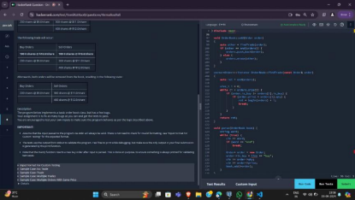
#include <map>
#include <set>
#include <list>
#include <cmath>
#include <ctime>
#include <deque>
#include <queue>
#include <stack>
#include <string>
#include <bitset>
#include <cstdio>
#include <limits>
#include <vector>
#include <climits>
#include <cstring>
#include <cstdlib>
#include <fstream>
#include <numeric>
#include <sstream>
#include <iomanip>
#include <iostream>
#include <algorithm>
#include <unordered_map>
using namespace std;
struct Order
{
bool is_buy = false;
int qty = 0;
double price = 0.0;
};
ostream& operator <<(ostream& os, const Order& order)
{
return os << (order.is_buy ? "buy " : "sell ")
<< order.qty << "@$" << setprecision(1)
<< fixed << order.price;
}
bool operator <(const Order& a, const Order& b)
{
return a.price < b.price;
};
class OrderBook {
public:
OrderBook() = default;
// formats and prints the orders as the test cases expect.
~OrderBook() {
Squarepoint Page 5
~OrderBook() {
auto itr = splitIntoBuyAndSellOrders();
std::sort(begin(orders), itr);
std::sort(itr, end(orders));
print();
}
// checks the opposing side's available orders.
// for a buy order, look at existing sell orders, and vice versa.
// if a trade is possible, update the order book accordingly.
// otherwise, insert the order into the book.
void add(Order order);
// print the order book
// IMPORTANT: the test cases depend on this method.
// please make sure this is the ONLY ouput that gets printed to stdout. void print();
private:
// returns an iterator to the best "match" for a given order.
// for buy orders, this would be the lowest sell price.
// for sell orders, the highest buy price.
// if no orders meet the criteria, return orders.end()
vector<Order>::iterator findTrade(const Order& order);
// split orders into buy and sell orders.
// return an iterator to the first sell order.
// all orders before the iterator are buy orders.
// all orders after are sell orders.
vector<Order>::iterator splitIntoBuyAndSellOrders();
vector<Order> orders;
};
vector<Order>::iterator OrderBook::splitIntoBuyAndSellOrders() {
return stable_partition(begin(orders),
end(orders),
[](const Order& order) { return order.is_buy; });
}
void OrderBook::print() {
for (const auto& order : orders)
cout << order << endl;
}
void OrderBook::add(Order order) {
while (order.qty > 0) {
auto other = findTrade(order);
if (other == end(orders)) {
// Aggregate orders if there is an existing order with the same price and type auto it = std::find_if(orders.begin(), orders.end(), [&order](const Order& existingOrder) {
return existingOrder.is_buy == order.is_buy && existingOrder.price == order.price;
});
if (it != orders.end()) {
it->qty += order.qty;
} else {
orders.push_back(order);
}
return;
} else {
// Match found, fulfill as much as possible
if (order.qty >= other->qty) {
order.qty -= other->qty;
orders.erase(other);
} else {
other->qty -= order.qty;
order.qty = 0;
}
}
Squarepoint Page 6
}
}
}
vector<Order>::iterator OrderBook::findTrade(const Order& order) { vector<Order>::iterator best_match = orders.end();
for (auto it = orders.begin(); it != orders.end(); ++it) {
if (order.is_buy != it->is_buy) {
if (order.is_buy) {
// Buy order: match with the lowest sell price
if (it->price <= order.price) {
if (best_match == orders.end() || it->price < best_match->price) {
best_match = it;
}
}
} else {
// Sell order: match with the highest buy price
if (it->price >= order.price) {
if (best_match == orders.end() || it->price > best_match->price) {
best_match = it;
}
}
}
}
}
return best_match;
}
void parse(OrderBook &book) {
string word;
while (true) {
cin >> word;
if (word == "end")
break;
Order order;
order.is_buy = (word == "buy");
cin >> order.qty >> order.price;
book.add(order);
}
}
int main() {
OrderBook book;
parse(book);
Order order = {true, 10, 11.0};
book.add(order);
}
URL HASHING
Squarepoint Page 7
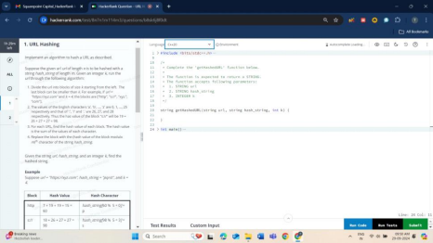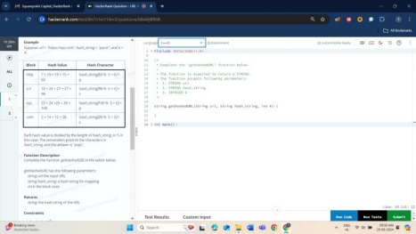
#include <iostream>
#include <string>
#include <vector>
using namespace std;
int charValue(char ch) {
if (ch >= 'a' && ch <= 'z')
return ch - 'a';
if (ch == '/')
return 26;
if (ch == '.')
return 27;
Squarepoint Page 8
return 27;
return -1;
}
string hashURL(const string& url, const string& hash_string, int k) {
int n = url.size();
int m = hash_string.size();
string result = "";

for (int i = 0; i < n; i += k) {
int hash_value = 0;

for (int j = i; j < i + k && j < n; j++) {
hash_value += charValue(url[j]);
}

result += hash_string[hash_value % m];
}

return result;
}
int main() {
string url = "https://xyz.com";
string hash_string = "pqrst";
int k = 4;

string hashed_url = hashURL(url, hash_string, k);

cout << "Hashed URL: " << hashed_url << endl;

return 0;
}
COMPANY USERNAMES:
Squarepoint Page 9
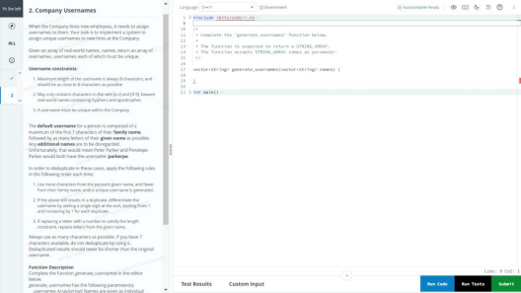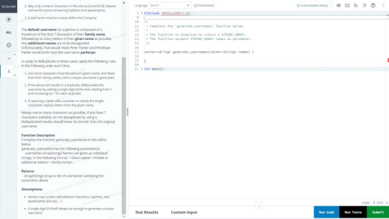
#include <bits/stdc++.h>
using namespace std;
// Helper function to clean the input name (remove hyphens and apostrophes)
string clean_name(const string &name) {
string result;
for (char ch : name) {
if (isalpha(ch)) {
result += tolower(ch);
}
}
Squarepoint Page 10
}
return result;
}
// Function to generate unique usernames
vector<string> generate_usernames(vector<string> names) {
unordered_map<string, int> username_count; // To keep track of usernames used and their counts
vector<string> result;
for (string &full_name : names) {
// Split the given full name into parts (given name, middle name(s), family name) vector<string> name_parts;
stringstream ss(full_name);
string word;
while (ss >> word) {
name_parts.push_back(clean_name(word));
}
if (name_parts.size() < 2) continue; // Skip if there is not enough data to generate username
string given_name = name_parts[0];
string family_name = name_parts.back();

// Start with a default username: first 7 characters of family name + as much of given name as possible
string username = family_name.substr(0, min(7, (int)family_name.size())); int remaining_length = 8 - username.length();
if (remaining_length > 0) {
username += given_name.substr(0, remaining_length);
}
// Attempt to adjust the username to make it unique by changing family/given name composition
int family_chars = min(7, (int)family_name.size());
int given_chars = remaining_length;
while (username_count.find(username) != username_count.end()) {
if (family_chars > 1) {
// Reduce the number of characters taken from the family name, and increase from given name
family_chars--;
given_chars = 8 - family_chars;
username = family_name.substr(0, family_chars) + given_name.substr(0, given_chars); } else {
// If reducing family name characters is not enough, append a number to make it unique int count = ++username_count[username];
if (username.length() == 8) {
// Replace the last character with a number
username[7] = '0' + count;
} else {
// Append a number to the username
username += to_string(count);
}
}
}
// Store the final unique username
username_count[username]++;
result.push_back(username);
}
Squarepoint Page 11
return result;
}
int main() {
vector<string> names = {
"Peter Parker",
"Penelope Parker",
"Tony Stark",
"Bruce Banner",
"Steve Rogers",
"Natasha Romanoff",
"Peter Parker", // Duplicate test
"Penelope Parker" // Another duplicate test
};
vector<string> usernames = generate_usernames(names);
for (const string &username : usernames) {
cout << username << endl;
}
return 0;
}
QUESTION 7
https://leetcode.com/problems/subarray-product-less-than-k/description/
class Solution {
public:
int numSubarrayProductLessThanK(vector<int>& nums, int k) {
if (k <= 1) {
return 0;
}
int i = 0, j = 0;
int n = nums.size();
int product = nums[0];
int ans = 0;
nums.push_back(1);
while (j < n) {
if (product < k) {
product *= nums[++j];
} else {
ans += j - i;
product /= nums[i++];
}
}
Squarepoint Page 12
}
ans += (j - i) * (j - i + 1) / 2;
return ans;
}
};
Squarepoint Page 13
DQA
30 September 2024 11:53
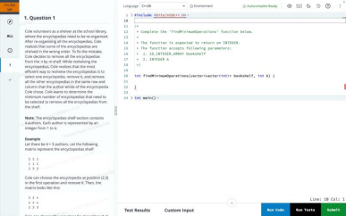S
Soln
#include <bits/stdc++.h>
using namespace std;
class DisjointSet {
vector<int> rank, parent, size;
public:
DisjointSet(int n) {
rank.resize(n + 1, 0);
parent.resize(n + 1);
size.resize(n + 1);
for (int i = 0; i <= n; i++) {
parent[i] = i;
size[i] = 1;
}
}
int findUPar(int node) {
if (node == parent[node])
return node;
return parent[node] = findUPar(parent[node]);
}
void unionBySize(int u, int v) {
Squarepoint Page 14
void unionBySize(int u, int v) {
int ulp_u = findUPar(u);
int ulp_v = findUPar(v);
if (ulp_u == ulp_v) return;
if (size[ulp_u] < size[ulp_v]) {
parent[ulp_u] = ulp_v;
size[ulp_v] += size[ulp_u];
}
else {
parent[ulp_v] = ulp_u;
size[ulp_u] += size[ulp_v];
}
}
};
class Solution {
public:
int minRemovals(vector<vector<int>>& shelf) {
int n = shelf.size();
int m = shelf[0].size();

// MaxRow and MaxCol are based on matrix dimensions, we treat rows and columns separately DisjointSet ds(n * m);
unordered_map<int, int> componentNodes;
// Loop through the grid and unite nodes based on the same row and column condition for (int i = 0; i < n; i++) {
for (int j = 0; j < m; j++) {
// Row-wise union if the same value appears in the row
for (int k = j + 1; k < m; k++) {
if (shelf[i][j] == shelf[i][k]) {
ds.unionBySize(i * m + j, i * m + k); // Connect row cells if values are the same }
}
// Column-wise union if the same value appears in the column
for (int k = i + 1; k < n; k++) {
if (shelf[i][j] == shelf[k][j]) {
ds.unionBySize(i * m + j, k * m + j); // Connect column cells if values are the same }
}
// Mark the current cell as seen
componentNodes[i * m + j] = 1;
}
Squarepoint Page 15
}
// Count unique components
int cnt = 0;
for (auto it : componentNodes) {
if (ds.findUPar(it.first) == it.first) {
cnt++;
}
}
// The number of removals is the total number of components
return cnt;
}
};
int main() {
vector<vector<int>> shelf = {
{2, 2, 1},
{2, 1, 1},
{3, 3, 3}
};
Solution sol;
cout << "Minimum removals to clean the shelf: " << sol.minRemovals(shelf) << endl;
return 0;
}

1 1 2
2 2 2
1 2 2
output = 3
Alt Ans.
def find_idx(L):
num=max(L)
for j in range (0,len(L)):
if L[j]==num:
return j

def get(L):
ans=0
visited=[False]*len(L)
Squarepoint Page 16
while False in visited:
x=[0]*n
y=[0]*m
for j in range (0,len(L)):
if visited[j]==True:
continue
u,v=L[j]
x[u]=x[u]+1
y[v]=y[v]+1
u=find_idx(x)
v=find_idx(y)
for j in range (0,len(L)):
if L[j][0]==u or L[j][1]==v:
visited[j]=True
ans=ans+1
return ans

for j in range (0,len(L)):
for k in range (0,len(L)):
M=dic.get(L[j][k],[])
M.append([j,k])
dic[L[j][k]]=M
ans=0
for x in dic:
count=get(dic[x])
ans=ans+count
print(ans)
C++
#include <iostream>
#include <vector>
#include <unordered_map>
#include <algorithm>
using namespace std;
int find_idx(const vector<int> &L) {
int num = *max_element(L.begin(), L.end());
for (int j = 0; j < L.size(); ++j) {
if (L[j] == num) {
return j;
}
Squarepoint Page 17
}
}
return -1; // This line should never be reached if the list is non-empty.
}
int get(const vector<pair<int, int>> &L, int n, int m) {
int ans = 0;
vector<bool> visited(L.size(), false);
while (find(visited.begin(), visited.end(), false) != visited.end()) {
vector<int> x(n, 0), y(m, 0);
for (int j = 0; j < L.size(); ++j) {
if (visited[j]) {
continue;
}
int u = L[j].first;
int v = L[j].second;
x[u]++;
y[v]++;
}
int u = find_idx(x);
int v = find_idx(y);
for (int j = 0; j < L.size(); ++j) {
if (L[j].first == u || L[j].second == v) {
visited[j] = true;
}
}
ans++;
}
return ans;
}
int main() {
int n = 3, m = 3, k = 2;
vector<vector<int>> L = {
{1, 1, 2},
{2, 2, 2},
{1, 2, 2}
};
Squarepoint Page 18
unordered_map<int, vector<pair<int, int>>> dic;
// Create the dictionary to group indices by value
for (int j = 0; j < L.size(); ++j) {
for (int k = 0; k < L[j].size(); ++k) {
dic[L[j][k]].emplace_back(j, k);
}
}
// Calculate the answer
int ans = 0;
for (auto &entry : dic) {
int count = get(entry.second, n, m);
ans += count;
}
cout << ans << endl;
return 0;
}
Hackerank Approach
For each unique value from 1 to K, greedily find the best intersection point, destroy the cells, keep doing the same until all cells with that value has been destroyed. To find the best intersection point it takes O(n*m), and the number of steps to destroy all would be at most (n,m) for each unique value, and there are at most K unique values. Therefore, the overall time complexity would be O(k*min(n,m)*n*m). Considering the worst case where n=m=100, k=50, it turns out to be O(50*100*100*100) = O(5*10^7).
QUESTION 2:
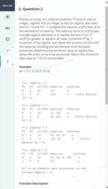 | 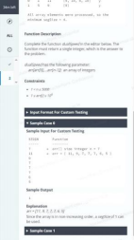

Squarepoint Page 19
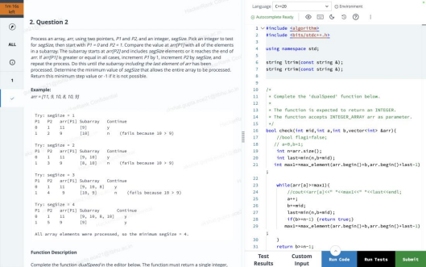
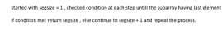
#include<bits/stdc++.h>
bool canProcessWithSegSize(const std::vector<int>& arr, int segSize) {
int n = arr.size();
int P1 = 0;
int P2 = 1;
while (P1 < n && P2 < n)
{
bool isValid = true;
for (int i = 0; i < segSize && P2 + i < n; ++i)
{
if (arr[P1] < arr[P2 + i])
{
isValid = false;
break;
}
}
if (isValid)
{
Squarepoint Page 20
{
P1++;
P2 += segSize;
} else
{
return false;
}
}
return true;
}
int findMinimumSegSize(const std::vector<int>& arr) {
int n = arr.size();

if (n <= 1) {
return 1;
}
for (int segSize = 1; segSize < n; ++segSize) {
if (canProcessWithSegSize(arr, segSize)) {
return segSize;
}
}
return -1;
}
int main() {
std::vector<int> arr = {11,9,10,8,10,9}; // Example array
int result = findMinimumSegSize(arr);
if (result != -1) {
std::cout << "Minimum segSize: " << result << std::endl;
} else {
std::cout << "No valid segSize found." << std::endl;
}
return 0;
}
Squarepoint Page 21
INFRA
30 September 2024 11:53
LINUX
7. Linux: Users Bulk Onboarding
Complete the file stub "/home/ubuntu/900026- linux-users-bulk-onboarding/script.sh" with one or more steps that do the following:
• Read the list of first and last names of employers to onboard from "/home/ubuntu/900026-linux users-bulk-onboarding/onboard.txt".
• Create the users with logins in the format "f_lastname", where "f" is the lowercase first letter of the first name.
• Put all the created users in the "onboarding" group.
• Force all created users to update their passwords at the next login.
Note
The completed solution will be evaluated in a new, clean environment. Be sure everything is in the "/home/ubuntu/900026-linux-users-bulk- onboarding" folder.
All the tasks should be done within a simple "sudo solve" execution invoked from the question directory.
• You have sudo access.
Grading
• The execution result of "sudo solve" invoked from the question directory solves the task.
Solution
#!/bin/bash
# Define the file path
FILE="/home/ubuntu/900026-linux-users-bulk-onboarding/onboard.txt"
# Check if the file exists
if [ ! -f "$FILE" ]; then
echo "File not found!"
exit 1
fi
# Create the "onboarding" group if it doesn't exist
if ! getent group onboarding >/dev/null; then
sudo groupadd onboarding
fi
# Loop through the onboard.txt file
while IFS=',' read -r firstname lastname
do
# Format the username as f_lastname (lowercase first letter of the first name)
username="${firstname:0:1,,}_$lastname"
# Create the user with the formatted username
if id "$username" &>/dev/null; then
echo "User $username already exists, skipping..."
else
sudo useradd -m -g onboarding "$username"
echo "User $username created."
fi
# Force user to change password at next login
sudo passwd -e "$username"
done < "$FILE"
echo "All users onboarded successfully."
Running the command
sudo chmod +x /home/ubuntu/900026-linux-users-bulk-onboarding/script.sh
sudo /home/ubuntu/900026-linux-users-bulk-onboarding/script.sh
Squarepoint Page 22
sudo /home/ubuntu/900026-linux-users-bulk-onboarding/script.sh
DOCKER:
Step 1: Create the script directory
First, ensure that the target directory exists. If it does not, create it:
bash
Copy code
mkdir -p /home/ubuntu/826087-docker-port-binding
Step 2: Create or edit the script file
You can use a text editor like nano to create the script:
bash
Copy code
nano /home/ubuntu/826087-docker-port-binding/script.sh
Step 3: Add the necessary commands to the script
In the nano editor, add the following lines to the script:
bash
Copy code
#!/bin/bash
# Run a new Docker container from the nginx image
sudo docker run -d --name my-container -p 8000:80 nginx
Step 4: Save and exit the editor
• Press CTRL + X to exit.
• Press Y to confirm saving changes.
• Press ENTER to save with the same filename.
Step 5: Ensure the script has execute permissions
Run the following command to make the script executable:
bash
Copy code
chmod +x /home/ubuntu/826087-docker-port-binding/script.sh
Step 6: Run the script
Change to the script's directory and execute it:
bash
Copy code
cd /home/ubuntu/826087-docker-port-binding
sudo ./script.sh
Step 7: Verify that the container is running
You can check that the Nginx welcome page is accessible by executing:
bash
Copy code
wget -qO- http://localhost:8000
Expected Output
If everything is set up correctly, you should see the HTML content of the Nginx welcome page as the
output of the wget command.
Summary of Commands
Here’s a summary of all the commands you need to run in order:
bash
Copy code
mkdir -p /home/ubuntu/826087-docker-port-binding
nano /home/ubuntu/826087-docker-port-binding/script.sh
# (Add the script content and save)
chmod +x /home/ubuntu/826087-docker-port-binding/script.sh
Squarepoint Page 23
chmod +x /home/ubuntu/826087-docker-port-binding/script.sh
cd /home/ubuntu/826087-docker-port-binding
sudo ./script.sh
wget -qO- http://localhost:8000
This will create the required Docker container and bind the specified ports.
REST API
Squarepoint Page 24
Squarepoint Page 25
#include <iostream>
#include <string>
#include <vector>
#include <sstream>
#include <algorithm>
#include <curl/curl.h>
#include <json/json.h> // Make sure you have a JSON library installed
using namespace std;
// Callback function to handle the response data from cURL
size_t WriteCallback(void* contents, size_t size, size_t nmemb, string* userp) {
size_t totalSize = size * nmemb;
userp->append((char*)contents, totalSize);
return totalSize;
}
Squarepoint Page 26
}
vector<string> weatherStation(string keyword) {
vector<string> results;
CURL* curl;
CURLcode res;
string readBuffer;
// Initialize cURL
curl_global_init(CURL_GLOBAL_DEFAULT);
curl = curl_easy_init();

if (curl) {
// Set the URL for the API request
string url = "https://jsonmock.hackerrank.com/api/weather/search?name=" + keyword; curl_easy_setopt(curl, CURLOPT_URL, url.c_str());
curl_easy_setopt(curl, CURLOPT_WRITEFUNCTION, WriteCallback);
curl_easy_setopt(curl, CURLOPT_WRITEDATA, &readBuffer);

// Perform the request
res = curl_easy_perform(curl);

// Check for errors
if (res != CURLE_OK) {
cerr << "curl_easy_perform() failed: " << curl_easy_strerror(res) << endl; return results;
}
// Clean up
curl_easy_cleanup(curl);
}
curl_global_cleanup();
// Parse the JSON response
Json::Value jsonData;
Json::Reader jsonReader;
if (jsonReader.parse(readBuffer, jsonData)) {
// Process the 'data' array from the JSON response
const Json::Value data = jsonData["data"];

// Iterate through each record
for (const auto& record : data) {
string cityName = record["name"].asString();
string temperature = record["weather"].asString();
const Json::Value status = record["status"];

// Assuming status contains "Wind: XKmph" and "Humidity: Y%"
string wind = status[0].asString(); // Get wind status
string humidity = status[1].asString(); // Get humidity status
// Extract numerical values for wind and humidity
size_t windStart = wind.find(':') + 2; // Find wind speed after "Wind: "
size_t windEnd = wind.find('K', windStart); // Find 'K'
string windSpeed = wind.substr(windStart, windEnd - windStart); // Extract wind speed
size_t humidityStart = humidity.find(':') + 2; // Find humidity after "Humidity: " size_t humidityEnd = humidity.find('%', humidityStart); // Find '%'
string humidityValue = humidity.substr(humidityStart, humidityEnd - humidityStart); // Extract humidity

// Create a result string in the desired format
results.push_back(cityName + ", " + temperature + ", " + windSpeed + ", " + humidityValue); }
} else {
cerr << "Failed to parse JSON data" << endl;
}
// Sort results by city name
sort(results.begin(), results.end());
return results;
}
int main() {
string keyword;
cout << "Enter the keyword: ";
cin >> keyword;
vector<string> weatherData = weatherStation(keyword);
for (const auto& record : weatherData) {
cout << record << endl;
}
return 0;
}
Squarepoint Page 27
MCQ
30 September 2024 12:06
Squarepoint Page 28

